Recap:

Overall

* Our group had been working on two stethoscope devices, the Littmann 3200 and our own stethoscope prototype called “splits”

Littmann 3200

* Java scripts and functions were developed to control certain features of the Littmann 3200
  + Development was done under a development license provided by 3M
  + Scripts and functions were developed using the Eclipse Java IDE

Splits

* The “splits” prototype consisted of commercially available products, including microphones, audio-jack splitters, Bluetooth modules, and ear-buds
  + The “splits” prototype was capable of recording and playing audio over the Bluetooth module (not simultaneously)
  + MATLAB scripts, functions, and a graphical user interface (GUI) were developed to operate the prototype
  + Using 3D printers, fixtures were designed to hold the components of the “splits” prototype together

Audio Analysis

* MATLAB was also implemented to develop spectral analysis algorithms
  + These algorithms were designed to detect acoustic features of heart sounds

Update:

Overall

* Our group focused on the development of more advanced prototypes by 3D printing stethoscope parts such as the diaphragm
* Additionally, our team began acquiring and testing components that can replicate and surpass the features of the Littmann 3200
  + Modern microcontrollers can be used to record, analyze, and playback sound waves over Bluetooth antennas

Splits

* Successfully developed a functional 3D printed stethoscope diaphragm (Figure 1)
  + The additive manufacturing process allows for the modification of the design in order to save material, maintain functionality, and thus reduce cost while increasing performance (Figure 1)
    - Designs can be made using a sparse infill in order to save material and space (Figure 1)
    - Wall thicknesses can be increased to avoid acoustic loss and increase the performance of the stethoscope (Figure 1)

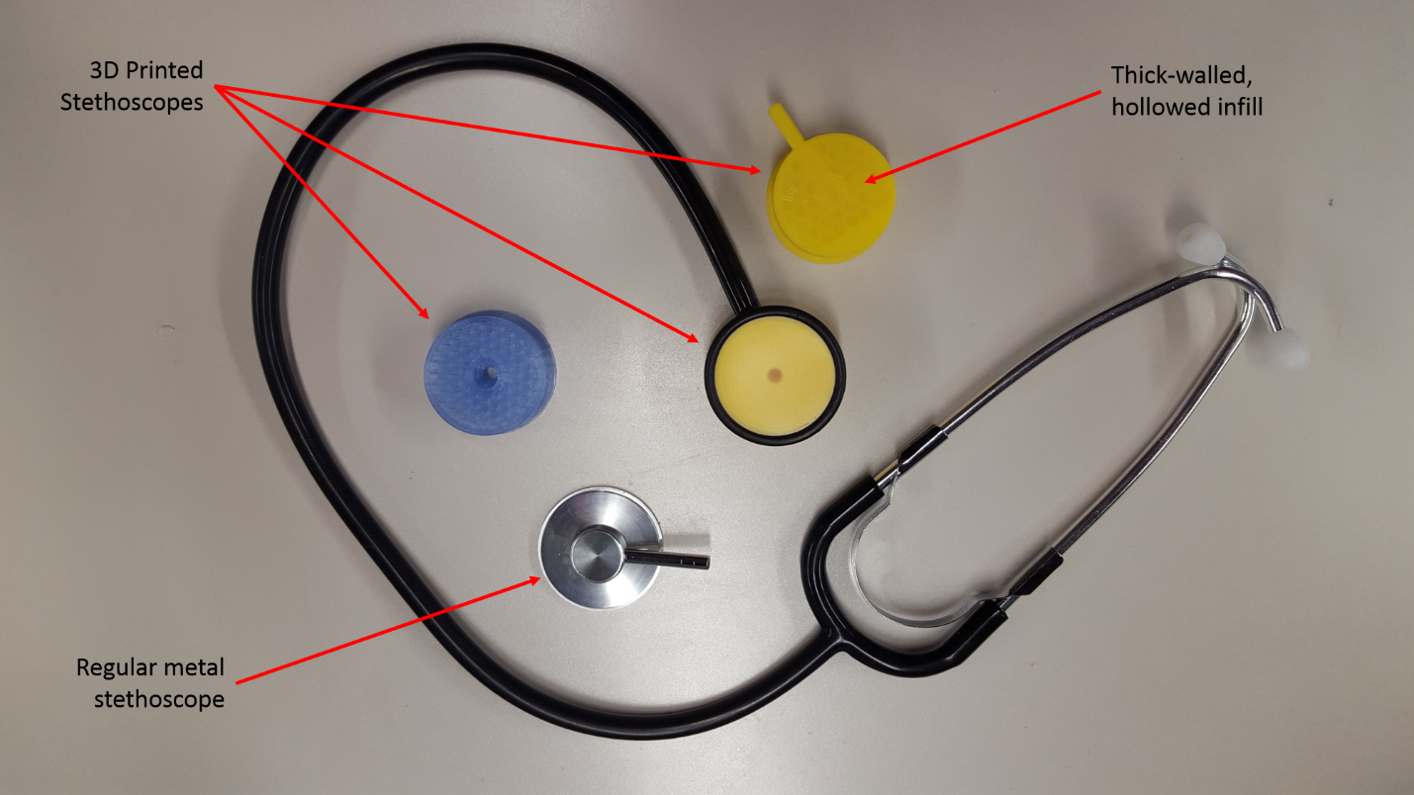

* Researched sound acquisition, analysis, and playback on different commercially-available, portable microcontrollers and components (Table 1)
  + Microcontrollers like the Arduino Pro Mini and the Teensy 3.2 can sample audio at 44kHz, making them capable of even performing voice recognition (Table 1)
  + Both microcontrollers are also Arduino compatible, making all software developed thus far reusable
  + The Electret microphone comes with an embedded amplifier (Table 1)
  + Adafruit (electronics manufacturer and distributer) has published several guides that will be used as reference for our prototype
    - These guides include a portable Arduino “Voice Changer” and a “Fast Fourier Transform” analyzer using the Teensy 3.2

|  |  |  |  |  |
| --- | --- | --- | --- | --- |
| **Component ID** | **Component Name** | **Manufacturer or Distributor** | **Component Type** | **Measurement or Functionality** |
| DEV-11114 | Arduino Pro Mini 328 - 3.3V/8MHz | SparkFun | Microcontroller | Control circuits |
| ADA-2756 | Teensy 3.2 3.3V | Adafruit | Microcontroller | Control circuits |
| ADA-1063 | Electret Microphone with Amplifier | Adafruit | Microphone | Record Sound |

Moving Forth:

* Our team will replicate the current relevant guides for sound manipulation and analysis
* Our team will develop a protocol for Bluetooth transfer of sound signals
* Our team will develop an stethoscope prototype capable of recording, analyzing, and playing back sound